DK01
Smart LED Strip Controller
Product Specification

Item： DK01
Version：v1.0
date：2018-07-18

All rights reserved.
The content can’t be modified without permission in this document

Historical Releases

Version | Modified Content | Writer | Auditing | date | Department
V1.0 | the first version | Jasmine | Ning Qing | 2018-07-18 | Product dept.

Product Introduction

1.1 Overview
DK01 is a smart LED strip controller which has lighting control function, the Smart LED strip controller has 3 ways PWM drive circuit to control RGB LED strip, the device can be controlled via Android and iOS mobile APP. Through APP, user could depose of operations such as local control, remote control, timer control, scene control.

1.2 Features
- Works with Amazon Alexa and the Google assistant, adjust the color and brightness via voice.
- Focus on 0~48W RGB 5050 LED strip lights within 10 meters.
- Switch 10 lighting effects under cyclic switching by a single press of the button
- APP local and remote control.
- ON/OFF, brightness, color, color temperature adjustment.
- Support multiple lighting effect include stream/breathe/flash/alternate lighting effect.
- User-define lighting scenes, one key to switch the lighting scenes.
- Set timer and event reminder.
- Device interaction
- Group control and multiple users control
- FOTA remote upgrade
- Support iOS/Android APP version.

1.3 Voice Control
The smart LED strip controller works directly with Amazon Alexa, the Google assistant, Tmall Genie and DuerOS voice platform, you can manage your devices through voice control like turn on/off. Assign a name to each Smart Touch Panel Switch and communicate with each wall switch by name when making a voice command.
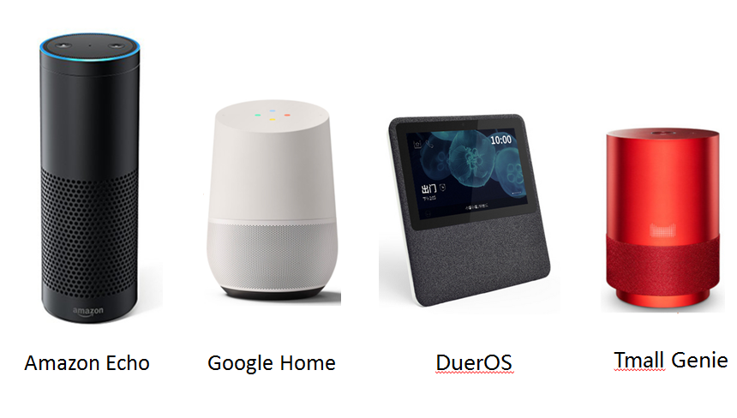

1.4 Product Appearance
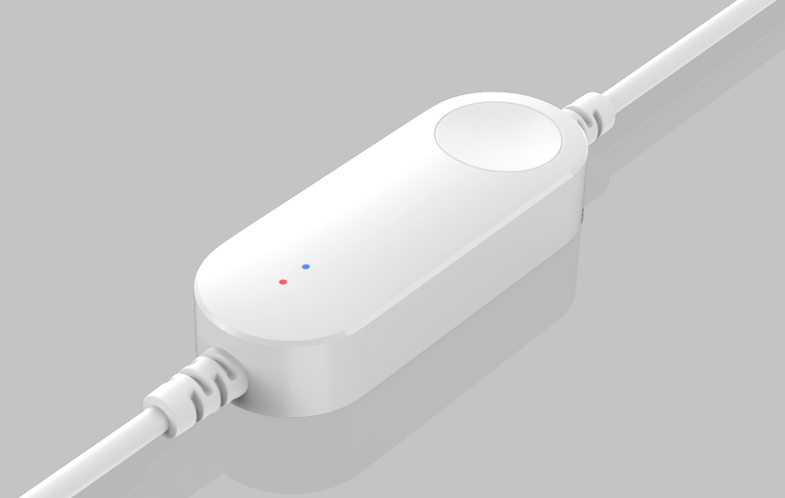
Figure2-1 DK01 front view

1.5 Product Diagram
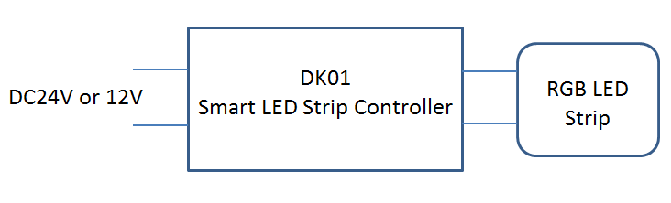
Figure 3-2 Pin Description

1.6 Connect LED controller to RGB strip light
The smart LED strip controller with a RGB LED strip and DC jack, which needs to be used in conjunction with power adapter and LED strip as below:
- SMD 5050 RGB LED strip lights (0~48W, within 10 meters )
- 24V/3A or 12V/3A(DC5521 jack, 5.5*2.1mm)

Application | Recommended power adapter  (DC5521 jack, 5.5*2.1mm)
12V RGB LED Strip | 12V/3A
24V RGB LED Strip | 24V/3A

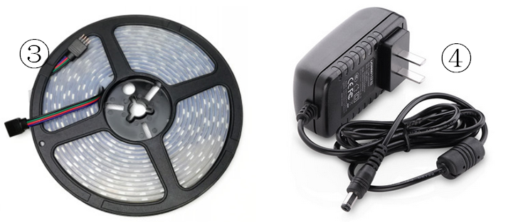
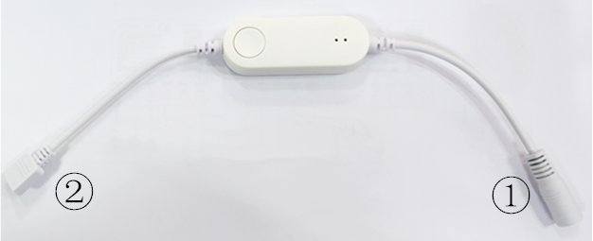
Figure 3-3 DK01 Pin figure
Connection Instruction:
1. ① is connected with ④
2. ② is connected with ③, Note: please connect according to arrow logo as shown below:
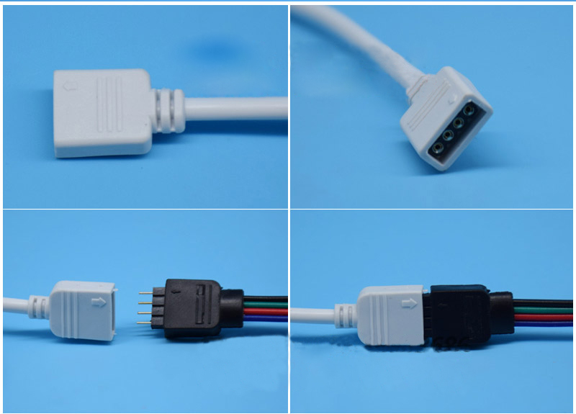

1.7 Operation Instruction
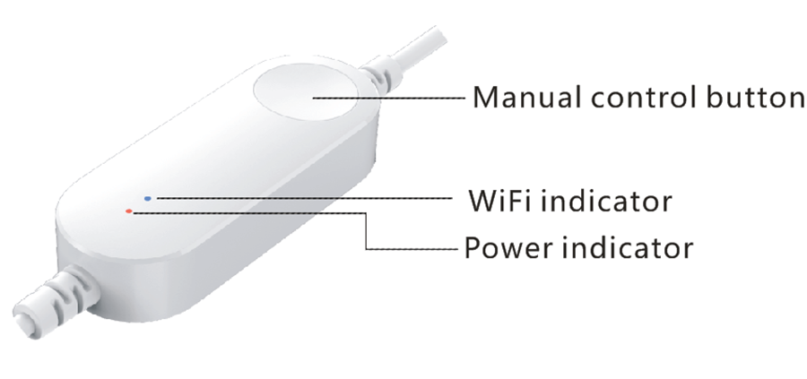
NO. |  | Details
1 | Manual control button | 1. Click the button to change lighting effect（Blue, Green. Red, White, Yellow, Purple, Cyan, Green-flash, Colorful, stream; under cyclic switching）  2. Double click to turn on/off LED strip lights  3. Restore factory settings: Long press manual control button for 5 seconds till the lighting is changing alternately in 3 colors(red→yellow→green).
2 | Power indicator(Red) | 1. When power indicator is on, The power supply of LED controller is opened.  2. When power indicator is off, The power supply of LED controller is turned off.
3 | WiFi indicator(Blue) | 1. When WiFi indicator is on, the device WiFi connnection is good.  2. When WiFi indicator is flashing，the device WiFi connnection is anormaly.

Software Support

2.1 APP Download
In DK01 evaluation, customer can test “Seetime Smart” APP to process configuration and evaluate function, now the “Seetime Smart” APP support Android 4.1 and iOS8.0 or above version, you can scan QR code below to install the APP, iOS/Android users can download “Seetime Smart” APP via App Store/Google Play.
APP Simplified Chinese name:” 时在智管家” , APP English name: ”Seetime Smart” .
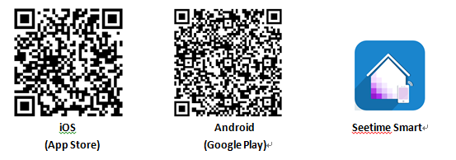
* APP supports: Android4.1 and iOS8.0 or above.
* For Android users, please scan QR code by QR scanner or browser.

2.2 APP Configuration

2.2.1 Add device in Easy mode
Step One: Connect the LED controller with RGB LED strip, and make sure it is powered on by 12V/3A power adapter.
Step Two: Open “Seetime Smart” APP, register and login, click “+” to add WiFi LED Strip Controller. Select “WiFi LED Strip Controller”, enter device secondary list, select “LED Strip Controller(with button)”.
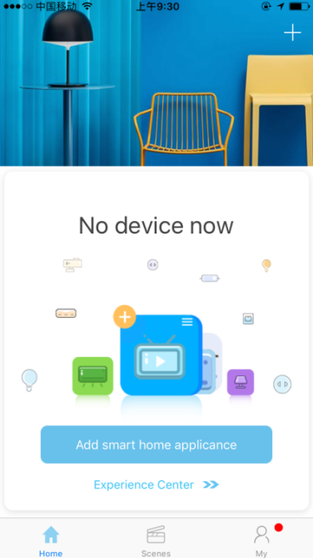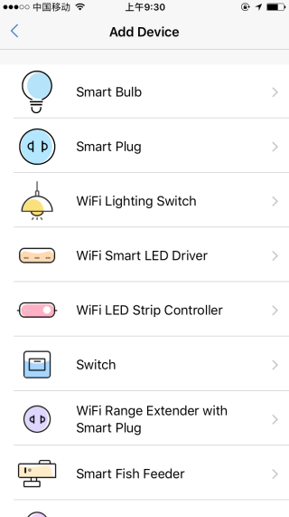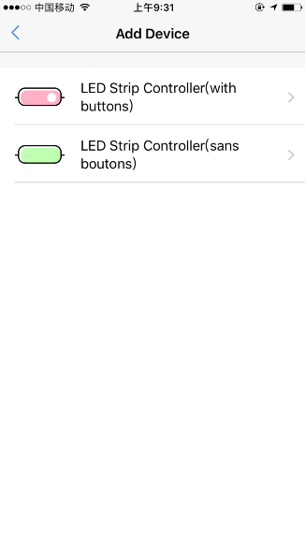
Step Three: Enter networking interface, it will show the WiFi your mobile phone connected, enter WiFi password, click “Next Step”. (The WiFi LED Strip Controller only supports 2.4GHz WiFi router)
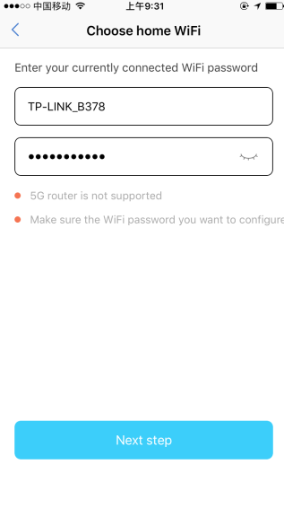
Step Four: Please power on the WiFi LED Strip Controller and check if the lighting is changing alternately in 3 colors(red→yellow→green), if yes, please confirm and enter Next Step. If not, please reset device according to following operation:
Long press manual control button for 5 seconds till the lighting changing alternately in 3 colors(red→yellow→green).
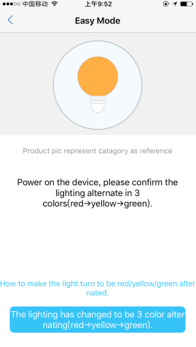
Once the device connected successfully, the lighting will turn white. The device will appear in device list.
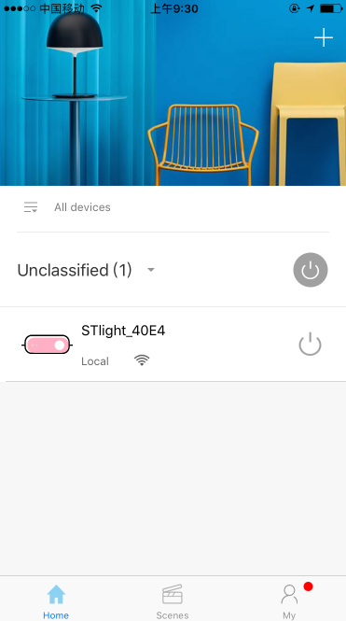

2.2.2 Add device in AP mode
Remark:
1. AP mode is a supplementary configuration way, if you failed configuration in Easy mode, please try AP mode to add device.
2. If there is no WiFi around the LED controller, you can try AP mode to add device, and follow configuration steps as followings.
Step One, If the configuration in Easy mode is failed, it will enter AP mode after 60 seconds of device reset. Select “Add device by AP mode”
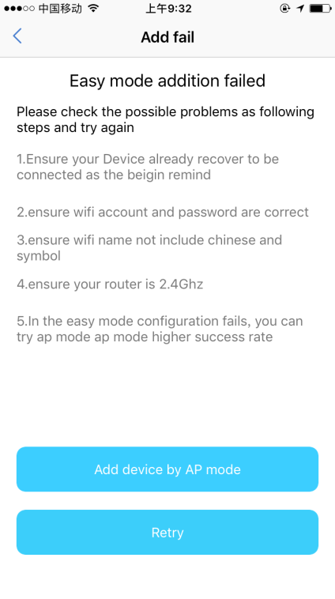
Step two, Go to WLAN setting in your smart phone and select the “see-time light_XXXX” for your WIFI, no need to input password.
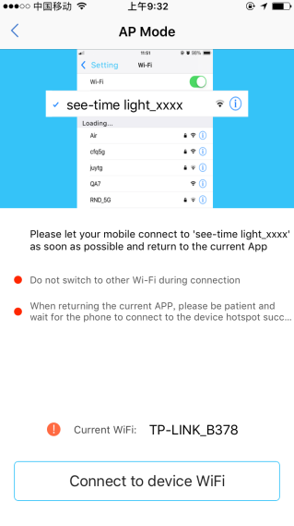
Step Three, Once you select the “see time light_XXXX ”, go back to app, click to select WiFi network (WiFi SSID) and input password, click “Next Step” to start connection. Once device configured successfully, you will find it in home page device list.
Remark:
1. If there is no WiFi around the LED Controller, you can clickand select “Direct control”, after connection successful, The LED controller will be in “Direct control” work mode, then the LED Controller can be only local controlled by APP, and can’t voice controlled by Alexa/the Google assistant.
2. If the device needs to be voice controlled by Alexa/the Google assistant or remote controlled by APP. The device must be added successfully and work in “WiFi control” work mode. So in this step, users must select WiFi network that works well.
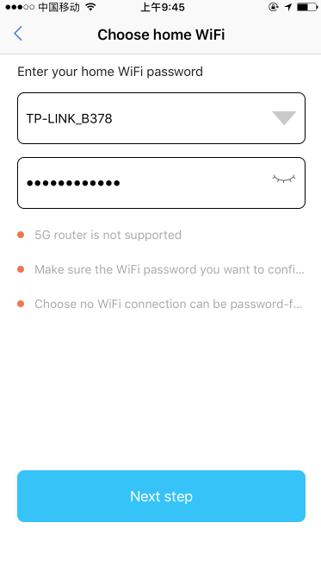

2.3 WiFi Work Mode
WiFi control: When there is WiFi around LED Controller , the LED Controller connect to router, mobile control the LED Controller via 4G/WiFi. The LED Controller is local/remote controlled by APP, and can be voice controlled by Alexa/the Google assistant/Tmall Genie/DuerOS.
Direct control: If there is no WiFi around WiFi LED Strip Controller , the mobile should be connected to WiFi LED Strip Controller WiFi signal “STswitch_XXXX”, then local control via APP. In direct control work mode, the WiFi LED Strip Controller can’t be remote controlled, and can’t be voice controlled by Alexa/the Google assistant/Tmall Genie/DuerOS.
Remark: After device connection successful, you can switch work mode in APP/device control page/senior settings.

2.4 FAQ
If you meet problems during configuration process, they can check following items and try again.
1. Please check whether the device is powered on.
2. Please check whether the phone is connected via WiFi.
3. Check routers or related: If router is dual-band router, select 2.4GHz network and add device.
4. Make sure the password entered in APP is correct when adding new device
5. Make sure the device reset successfully, please follow the steps as below:
Long press manual control button for 5 seconds till the lighting is changing alternately in 3 colors(red→yellow→green).
6. If the connection with Alexa/the Google assistant/Tmall Genie/DuerOS is not successful, please try again according to this manual, thanks for your support.

2.5 APP Function

2.5.1 APP Function
- Brightness/color/color temperature adjustment
- Group control,
- T2C lighting control settings:
- Five lighting effects: stream, breathe, flash, colorful, normal
- Set timer and event reminder
- Device share
- Game interation

2.5.2 T2C Lighting Control Setting
1. Execute lighting effect in APP, Users set brightness/effect/color temperature they need to set scenes, and click the button to change.
2. Add/delete/sort the lighting scenes in APP
3. There are 10 lighting scenes in default for T2C lighting control.
Scene 1: Normally on; Blue
Scene 2: Normally on; Green
Scene 3: Normally on; Red
Scene 4: Normally on; White
Scene 5: Normally on; Yellow
Scene 6: Normally on; Purple
Scene 7: Normally on; Cyan
Scene 8: Flash; Green
Scene 9: Colorful
Scene 10: Stream

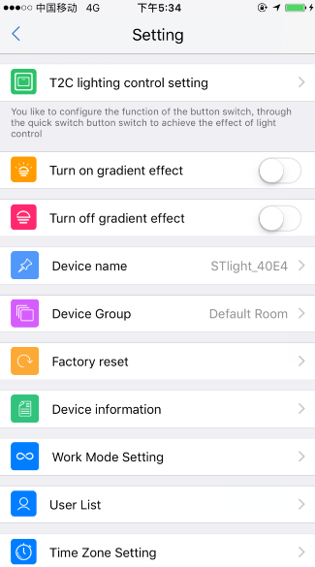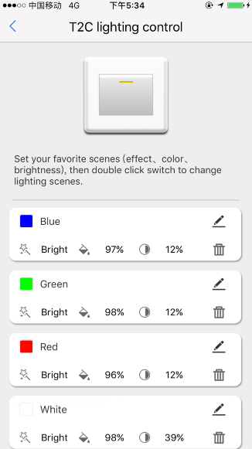

Integration

5.1 Set “Alexa” APP
Remark: If you want to voice control your device with the Google assistant, the device must be added successfully and work in WiFi control work mode.
1. Once install the APP, the APP will ask you to register, select language and enter your email, input verification code and create a password. If you could not see the verification code well, you can click the code button to refresh and input again.
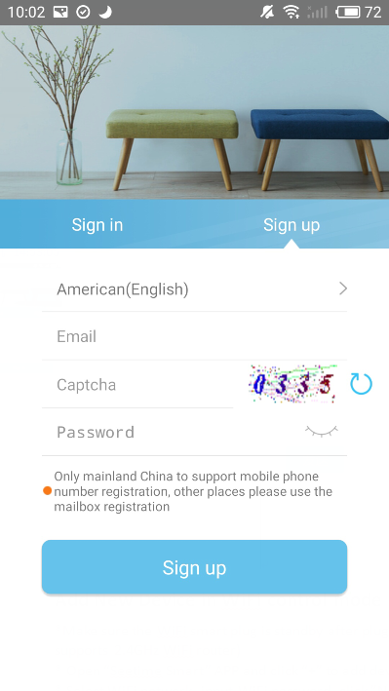

2. Once devices configured successfully, set a suitable name for your device, without unique names, you will be difficult to control the device via your voice with Alexa.
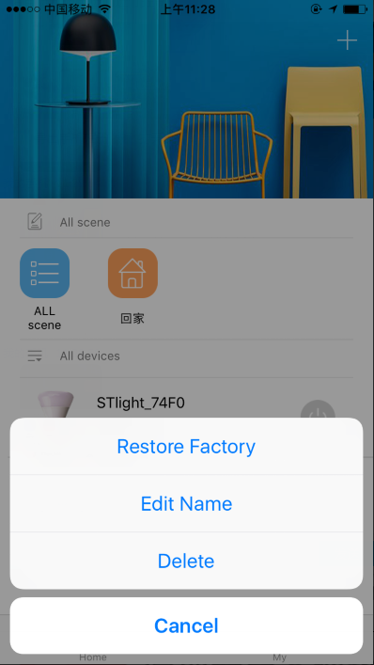
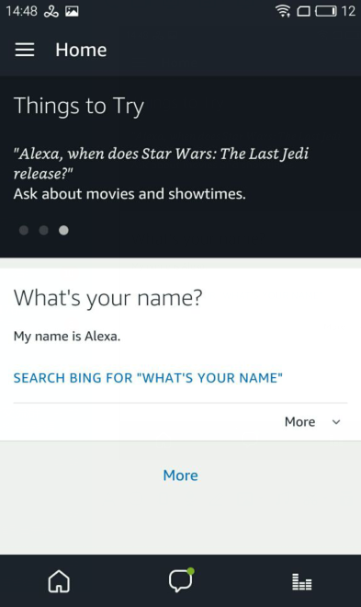
3. Open “Alexa” APP, Click . (As below highlighted)

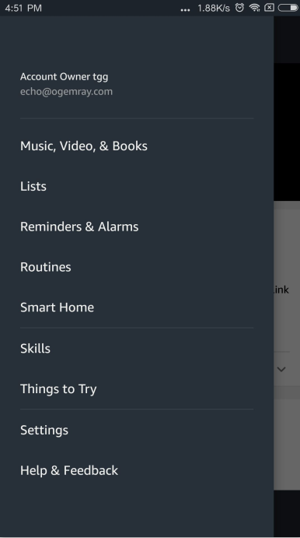
4. Click . (As below highlighted)
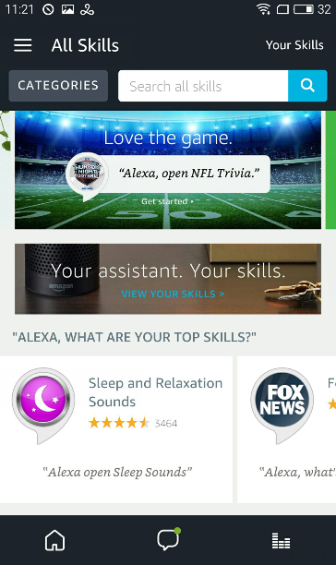
5. Input “seetime” to search skills, click search (See below highlighted)
6. Click “seetime” and enter.
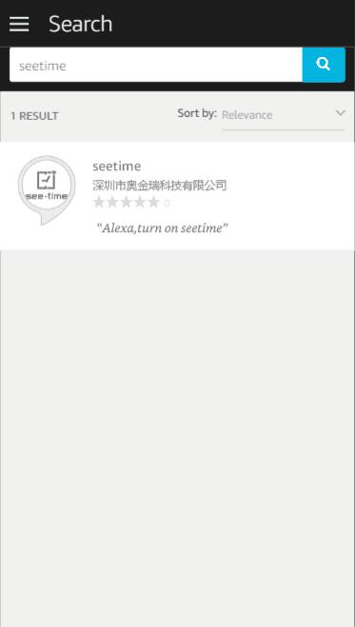
7. Click
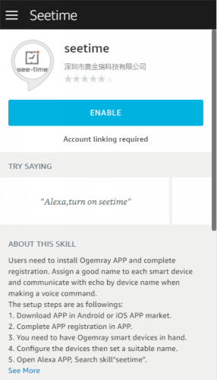
8. Input your “Seetime Smart” APP account and password which you have registered. (Attention: this is not the account and password of Alexa APP). Click
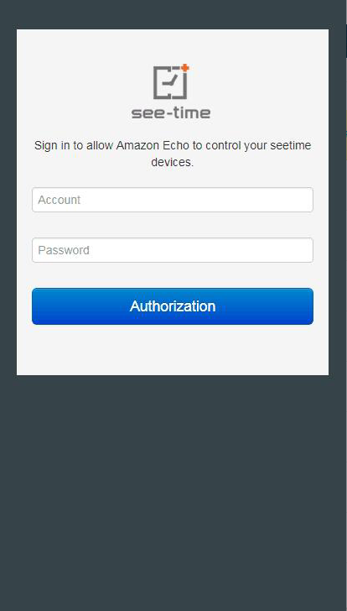
9. Close this window to discover smart devices you can control with Alexa
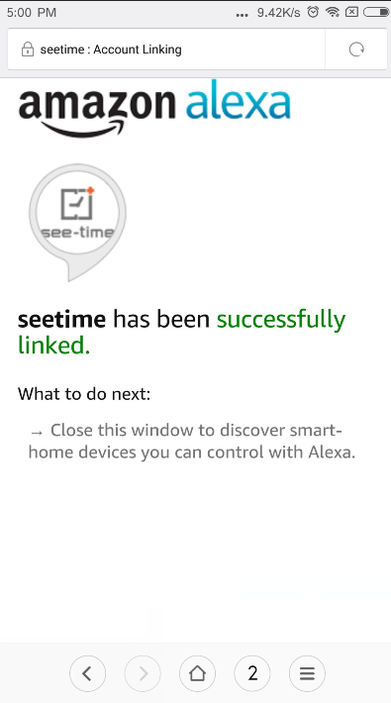
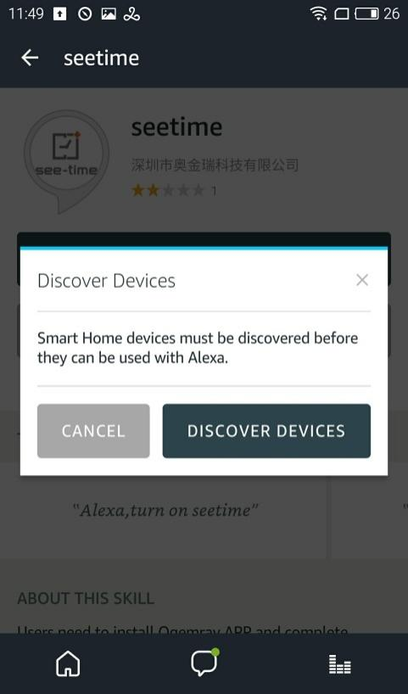
10. Click , then looking for devices.

11. Alexa is looking for devices
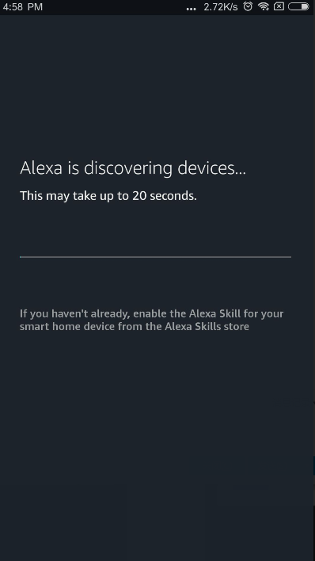
12. If successful, you will find the device list, then you can voice control the smart plug with Alexa
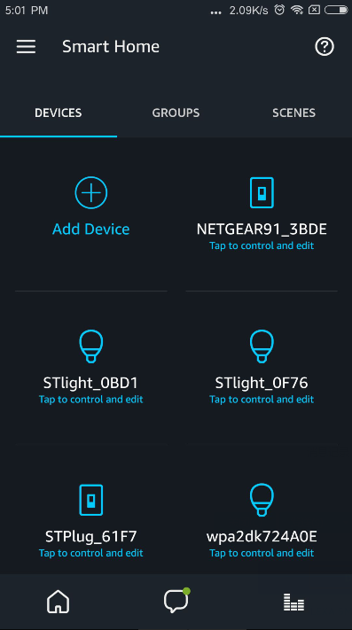

13. If failed, you will not find device list, please check FAQs to find out reasons, then discover devices again in the following interface. Click “Add Device”, Alexa will help you discover devices again.
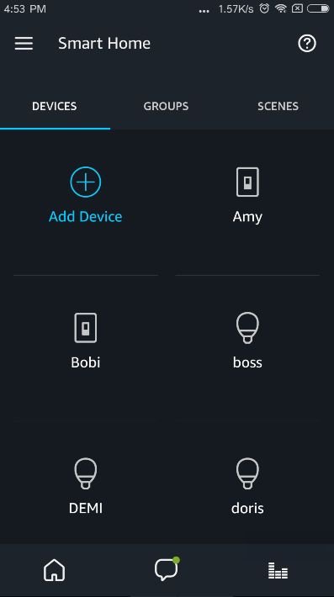
14. If users do not find the interface of discover above, they need to enter Smart Home interface, click “Smart Home”.
15. Click “Add Device”
16. After connection, try saying following commands to control the smart bulb.
Alexa, Turn on <device name>
Alexa, Turn off <device name>
Alexa, Set <device name> to daylight
Alexa, Set <device name> to warmwhite
Alexa, Set <device name> to 50%
Alexa, Decrease <device name> by 80%
Alexa, Increase <device name> by 80%
Alexa, discover my smart home devices

5.2 Set “Home” APP
Remark: If you want to voice control your device with the Google assistant, the device must be added successfully and work in WiFi control work mode.
1. Open “Home” APP, click
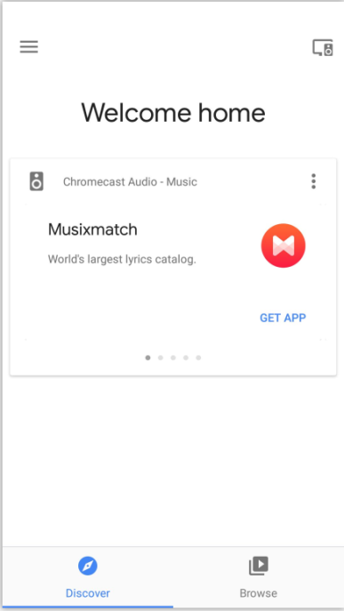
2. Click and enter
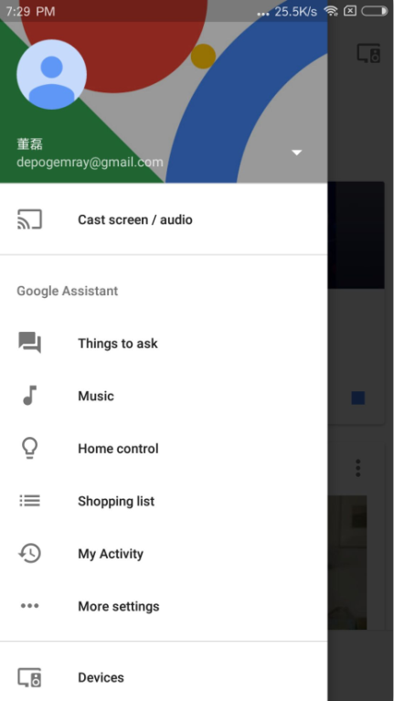
3. Scroll down the services list to find “seetime”, click 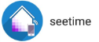
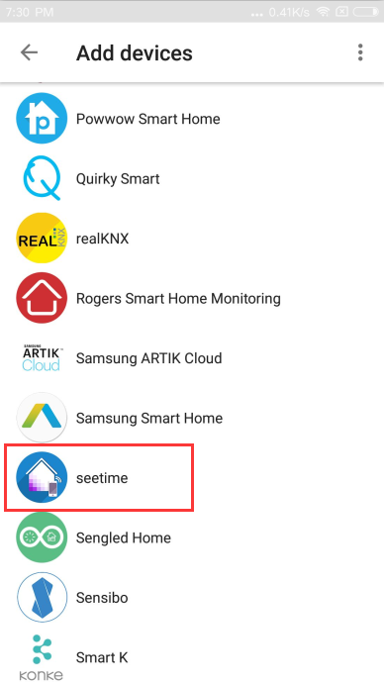
4. Input your “Seetime Smart” APP account and password which you have registered. (Attention: this is not the account and password of “Home” APP). Click
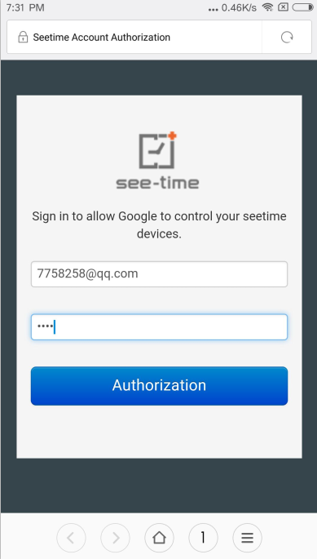
5. Click “OK” to open Google.
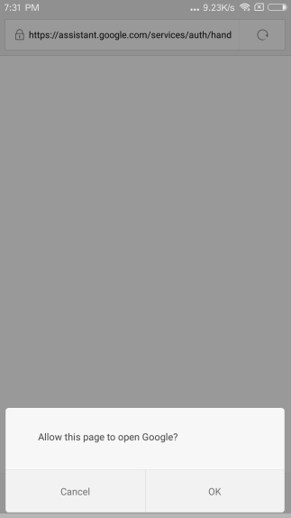
6. Google is linking your seetime account.
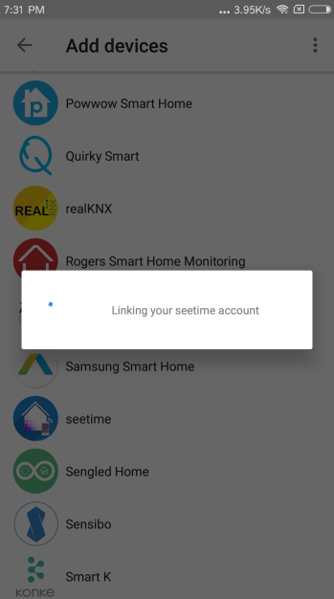
7. You can find the device list which has been configured by your “Seetime Smart” APP account. You can set a good name and assign room in “Home” APP. Click button you can find linked services.
Remark: Without unique name, you will be difficult to control the device via your voice, you can also voice control the devices by the name set in “Seetime Smart” APP.
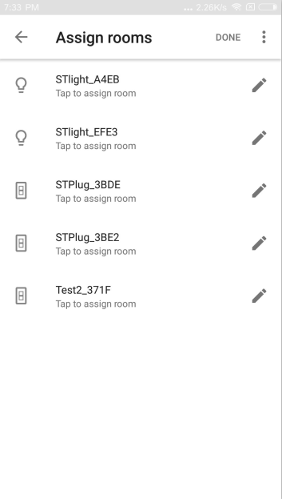
8. The following picture is linked services list.
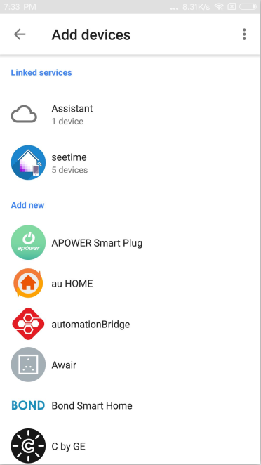
9. Then you can try saying following commands to control the bulb.
- Turn on/off
“Ok Google, turn on the <device name>”
“Ok Google, turn off the <device name>”
- Dim or brighten the light
“Ok Google, Brighten the <device name>”
“Ok Google, Dim the <device name>”
“Ok Google, Brighten the <device name> 20%”
“Ok Google, Dim the <device name> 20%”
- Verify that Google Home reports the correct status of the device.
“Ok Google, Is the <device name> on?”
“Ok Google, Is the <device name> off?”

Or you can try another queries as you want, like “Hi Google”, “Hey Google” or others.

10. After service linked, if you add new devices in “Seetime Smart” APP, you need to unlink “seetime” service then link the service again to refresh devices list, click “Home control”.
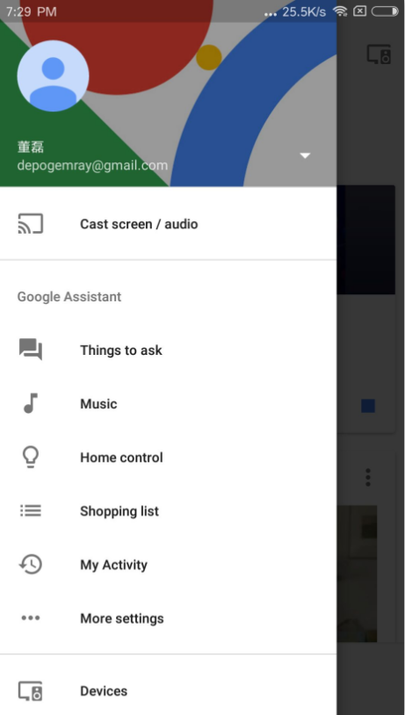
11. Click , enter linked services list.
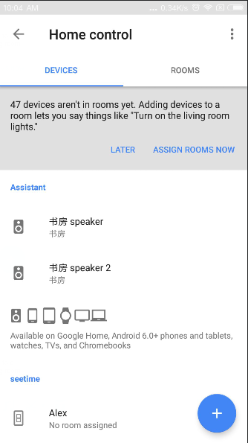
12. Click 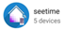
13. Click “UNLINK” to unlink seetime service and “Seetime Smart” APP account.
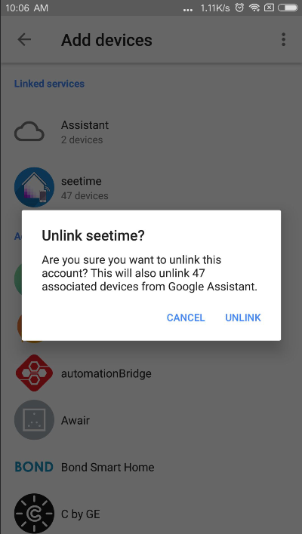
14. Please try to link “seetime” service and add devices again according to above steps 1-7 in this chapter. Then you can try saying commands in the step 9 of this chapter to voice control devices.

Product Specification
Table 5-1 DK01 Specification
Protocol and interface standard
WiFi Standard | IEEE 802.11b/g/n
WiFi Features
WiFi work mode | STA/AP/STA+AP/Smart Config
Security Specialty | None,WEP,WPA-PSK,WPA2-PSK (TKIP/AES)
WiFi RF Parameters
Frequency | 2.4GHz-2.5GHz (2400M-2483.5M)
RF Power | 802.11b (11Mbps): 18 +/-1.5dBm
RF Power | 802.11g (54Mbps): 15 +/-1.5dBm
RF Power | 802.11n (72.2Mbps): 14 +/-1.5dBm
Application
Applicable LED strip | 0~48W SMD 5050 RGB LED strip lights within 10 meters
Dimming Type
Dimming Type | 3 ways PWM
Power Input
Power Input | DC12V/3A or DC24V/3A
Output
Output Voltage | 3 ways PWM
Dimming Range | 0%~100%
Work environment
Work temperature | -10ºC to +50ºC
Storage temperature | Normal temperature
Work humidity | 5% to 60% (No condensing)
Physical Parameters
Shell material | ABS
Dimensions | 64.8*24.0*13.0mm
Indicator | Power indicator(Red), WiFi indicator(Blue)
DC Jack | DC power supply interface  5521 DC Jack (5.5mm*2.1mm)
LED controller output | RGB
RF Range
Indoor: 40m, Outdoor: 80m (varies with the environment)
Package
DK01 Smart LED Strip Controller
User manual
Packaging box

Approval and Certification
Table 6-1 Approval and Certification
Certification | Approval
CE | Ongoing
FCC | Ongoing
RoHS | Pass

Disclaimer
These material and information are provided “as is” without warranty of any kind, either express of implied, including but not limited to, the implied warranties of merchantability, fitness for a particular purpose or non-infringement.
We use reasonable efforts to include accurate and up-to-date information on this document, it does not, however, make any representations as to its accuracy or completeness of the information, text, graphics, links or other items contained within these materials. Your use of this Document is at your own risk. Ogemray, its suppliers, and other parties involved in creating and delivering this Document’s contents shall not be liable for any special, indirect, incidental, or consequential damages, including without limitation, lost revenues or lost profits.

